Cloud Storage

Definition
# Source: AI Source: Provided by: [Data Path: Persons Table -> ID Column: 1, Name_En Column: Motasem Essam] -> From: [Chatgpt (GPT‑5 Mini)] on [12/10/2025]
Cloud storage is a method of storing data on remote servers accessed via the internet.
- Data is stored in data centers managed by cloud providers.
- Users can upload, access, and share data from anywhere using devices connected to the internet.

Key idea:
# Source: AI Source: Provided by: [Data Path: Persons Table -> ID Column: 1, Name_En Column: Motasem Essam] -> From: [Chatgpt (GPT‑5 Mini)] on [12/10/2025]
Cloud storage is like a virtual filing cabinet accessible from any location with internet access.

Characteristics of Cloud Storage
# Source: AI Source: Provided by: [Data Path: Persons Table -> ID Column: 1, Name_En Column: Motasem Essam] -> From: [Chatgpt (GPT‑5 Mini)] on [12/10/2025]
- Remote access: Data can be accessed from multiple devices and locations
- Scalable: Storage can grow as needed without buying physical hardware
- Secure: Most providers offer encryption, backups, and disaster recovery
- Collaboration-friendly: Multiple users can access and edit shared data
- Pay-as-you-go: Cost depends on storage space and usage

Example
# Source: AI Source: Provided by: [Data Path: Persons Table -> ID Column: 1, Name_En Column: Motasem Essam] -> From: [Chatgpt (GPT‑5 Mini)] on [12/10/2025]
A company stores its sales and customer data on a cloud platform like Google Drive or Dropbox:
Customer_Sales.xlsx
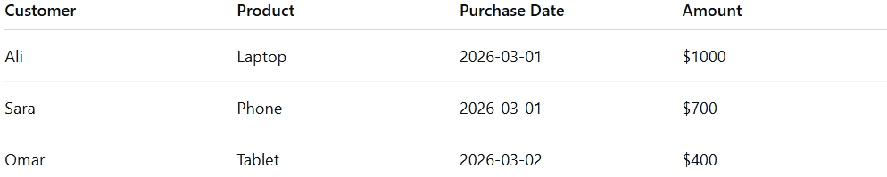
Customer | Product | Purchase Date | Amount
Ali | Laptop | 2026-03-01 | $1000
Sara | Phone | 2026-03-01 | $700
Omar | Tablet | 2026-03-02 | $400
- Employees can access this file from their laptops, phones, or tablets.
- Data is automatically backed up and shared without manual copying.

Advantages
# Source: AI Source: Provided by: [Data Path: Persons Table -> ID Column: 1, Name_En Column: Motasem Essam] -> From: [Chatgpt (GPT‑5 Mini)] on [12/10/2025]
- Accessible anywhere, anytime
- Easy collaboration among multiple users
- Automatic backups and security features
- Scalable storage for small or large datasets
- No need to maintain physical storage hardware

Disadvantages
# Source: AI Source: Provided by: [Data Path: Persons Table -> ID Column: 1, Name_En Column: Motasem Essam] -> From: [Chatgpt (GPT‑5 Mini)] on [12/10/2025]
- Requires a reliable internet connection for access
- Dependent on third-party providers – potential service outages
- Ongoing subscription costs for large storage or premium features
- Security and privacy concerns if data is sensitive
- Limited control over hardware and infrastructure

Example Section
# Source: AI Source: Provided by: [Data Path: Persons Table -> ID Column: 1, Name_En Column: Motasem Essam] -> From: [Chatgpt (GPT‑5 Mini)] on [12/10/2025]
A marketing team stores all campaign data in the cloud.
Team members from different locations can access and update the same data in real-time.

Campaign | Start Date | Budget | Leads Generated
Summer Sale | 2026-06-01 | $5000 | 120
Winter Promo | 2026-12-01 | $7000 | 180
Because the data is stored on remote servers and accessible online, this is cloud storage.

